Web API Design with SpringBoot Week 2 Coding Assignment

**Points possible:** 70

|  |  |  |
| --- | --- | --- |
| Category | Criteria | % of Grade |
| Functionality | Does the code work? | 25 |
| Organization | Is the code clean and organized? Proper use of white space, syntax, and consistency are utilized. Names and comments are concise and clear. | 25 |
| Creativity | Student solved the problems presented in the assignment using creativity and out of the box thinking. | 25 |
| Completeness | All requirements of the assignment are complete. | 25 |

**Instructions:** In Eclipse, or an IDE of your choice, write the code that accomplishes the objectives listed below. Ensure that the code compiles and runs as directed. Take screenshots of the code and of the running program (make sure to get screenshots of all required functionality) and paste them in this document where instructed below. Create a new repository on GitHub for this week’s assignments and push this document, with your Java project code, to the repository. Lastly, in the Learning Management System, click the “Add Submission” button and paste the URL to your GitHub repository.

**Coding Steps:**

Follow the tutorial in the homework section to build an API. Paste screenshots of your code and your postman requests and responses to show the API works. Push your project to GitHub and paste the link below.

**Screenshots of Code:**

**Eclipse Shots:**

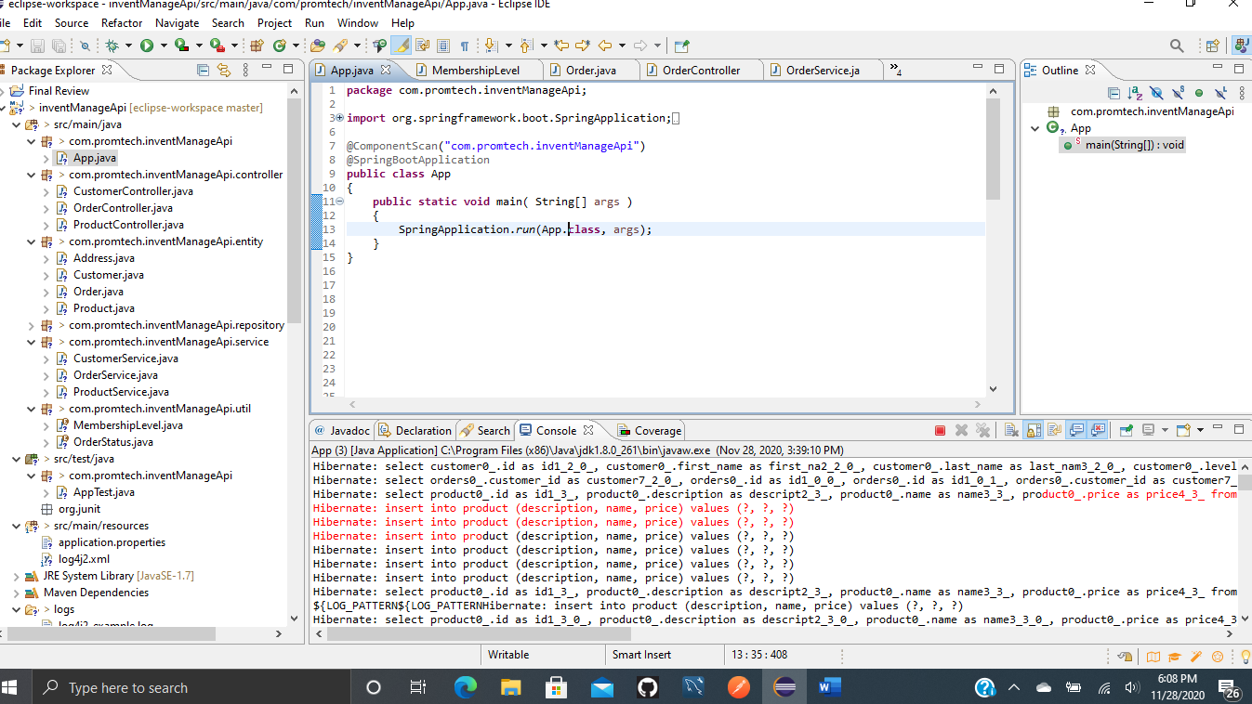

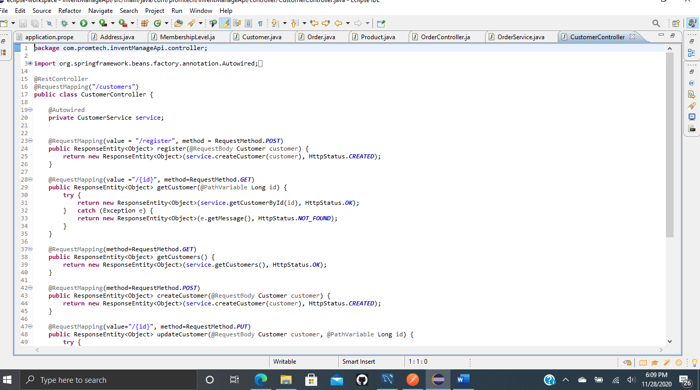

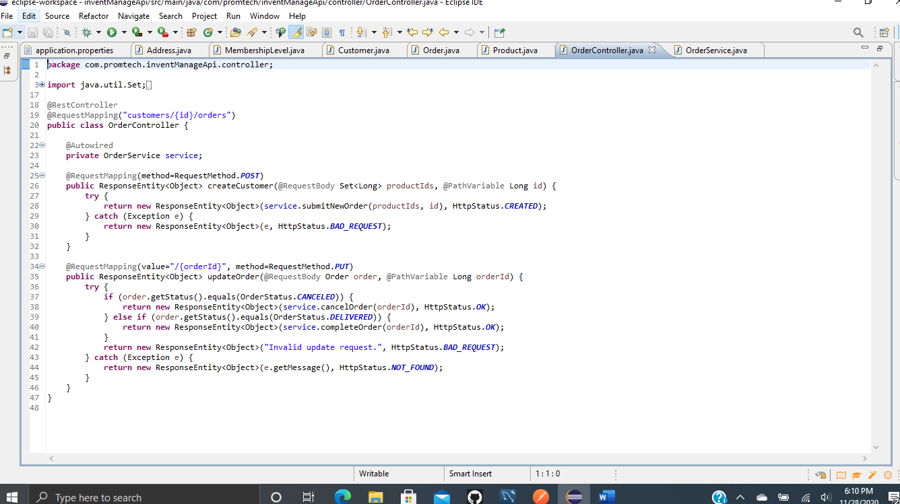

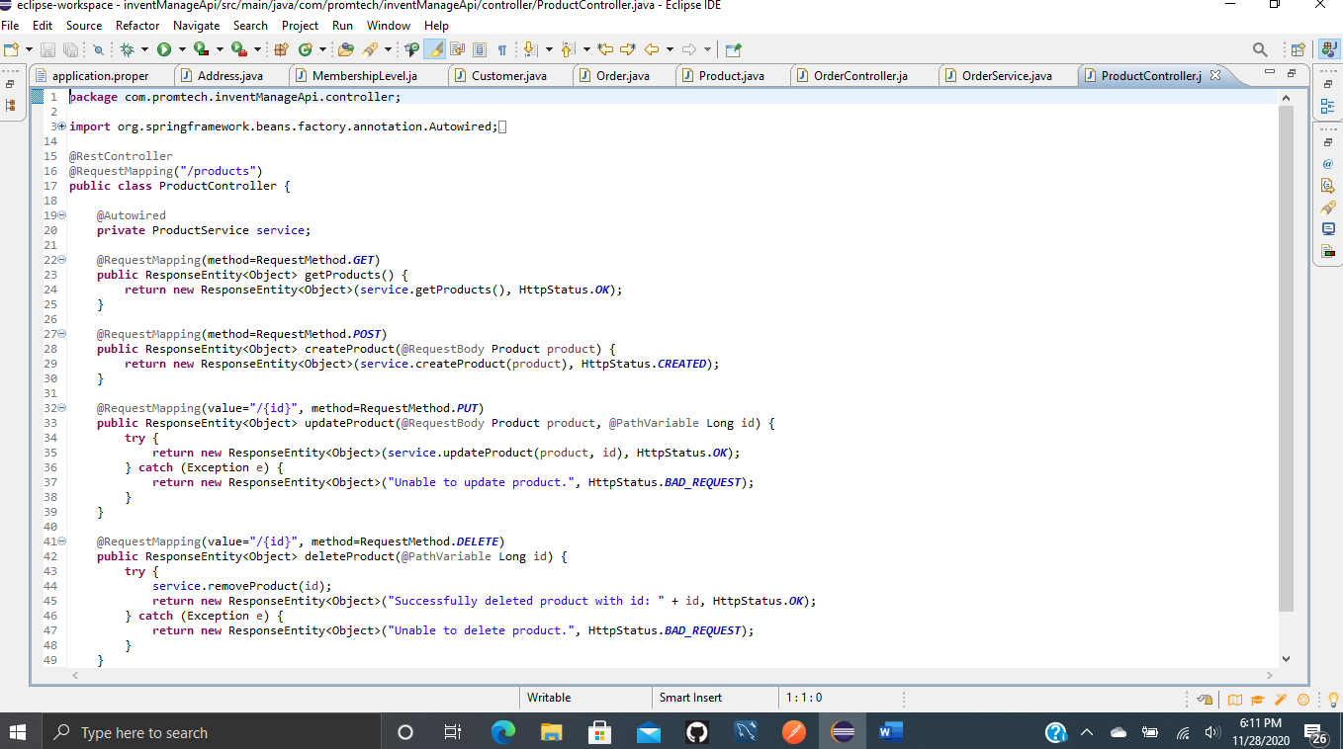

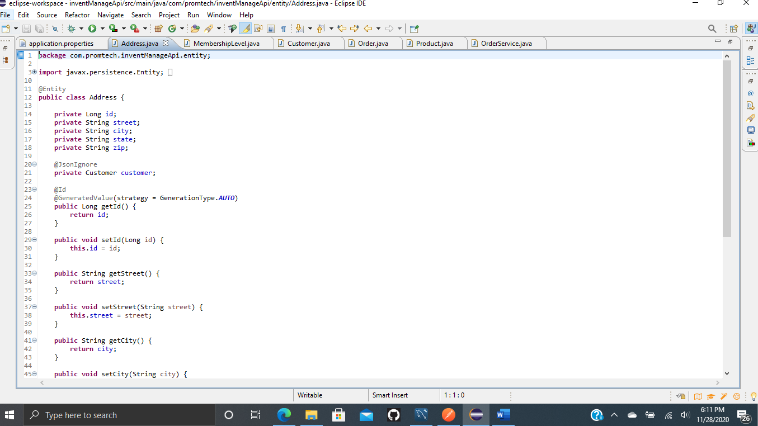

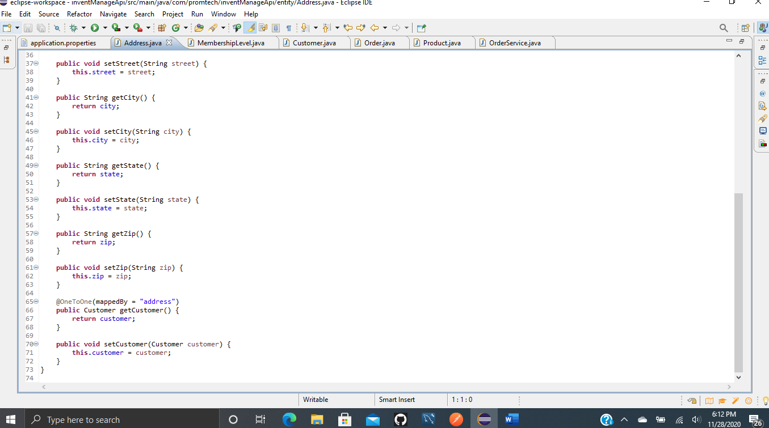

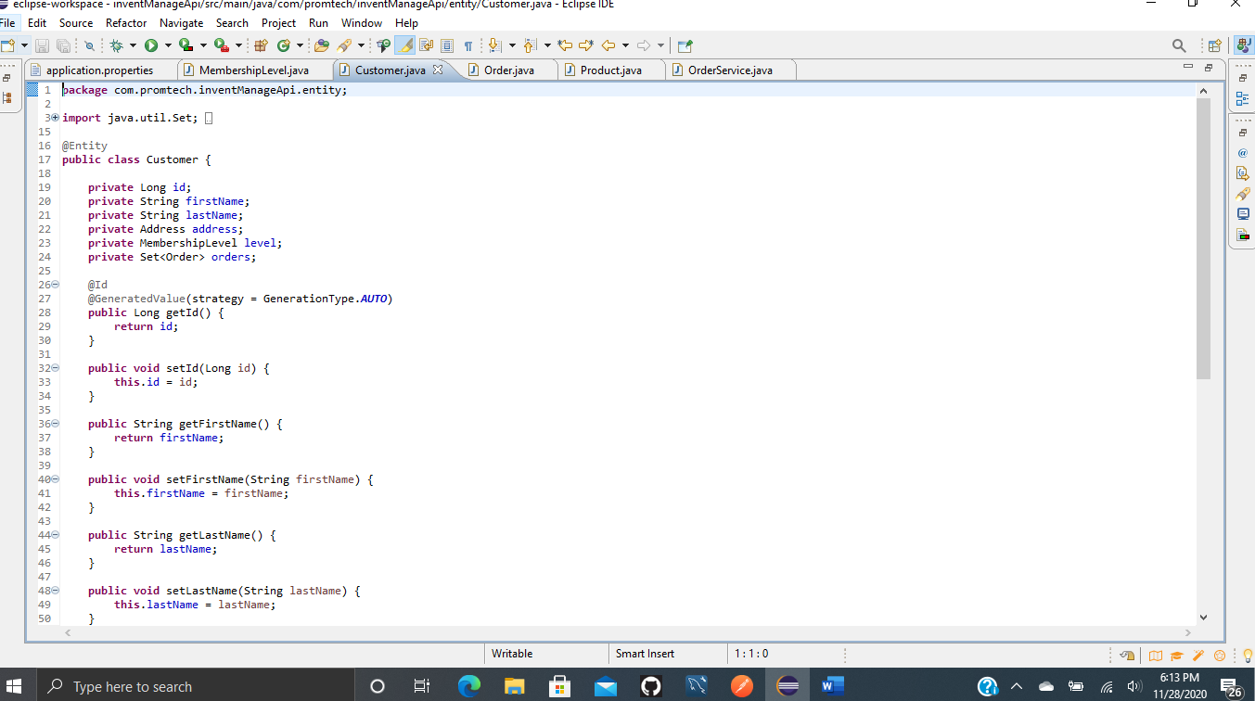

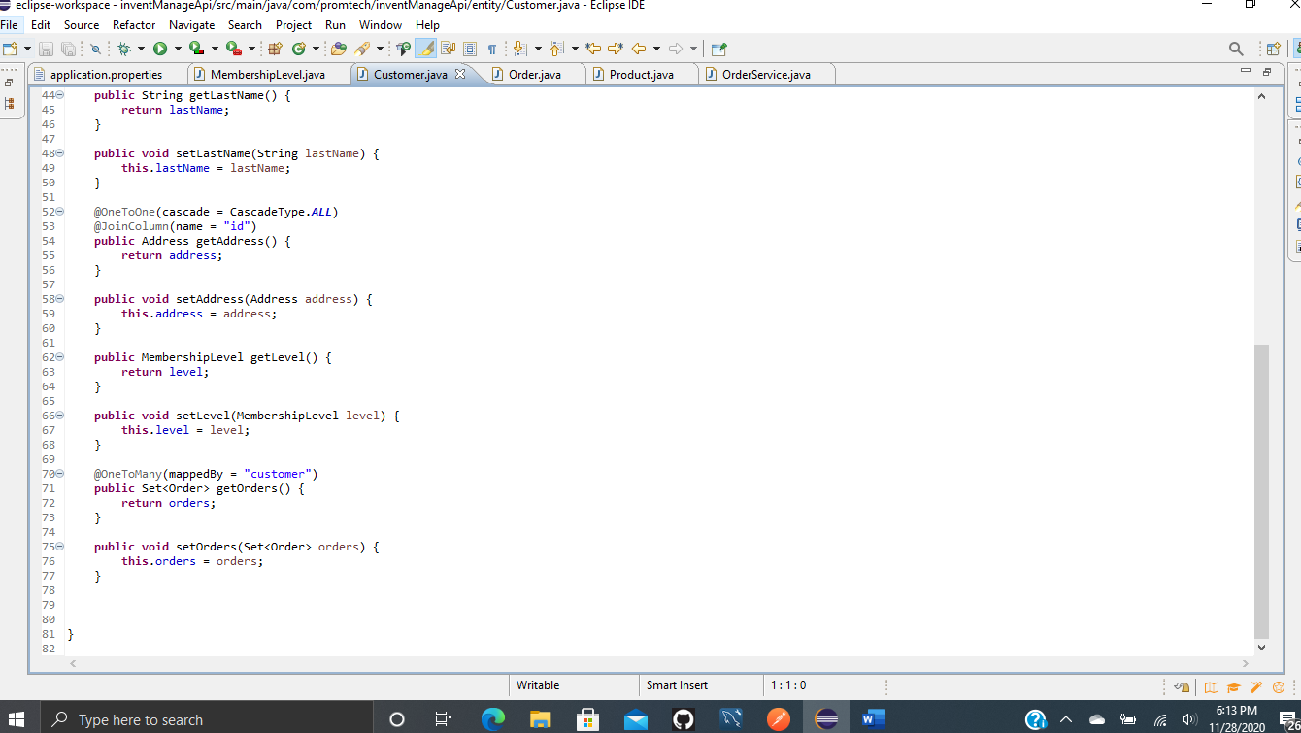

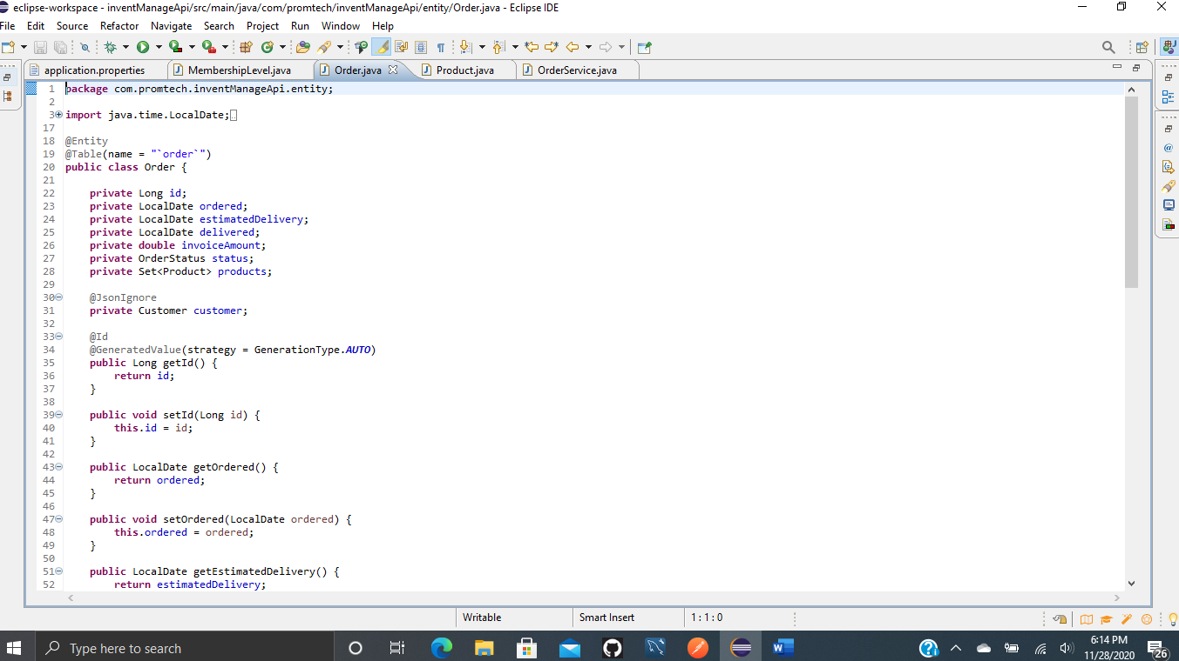

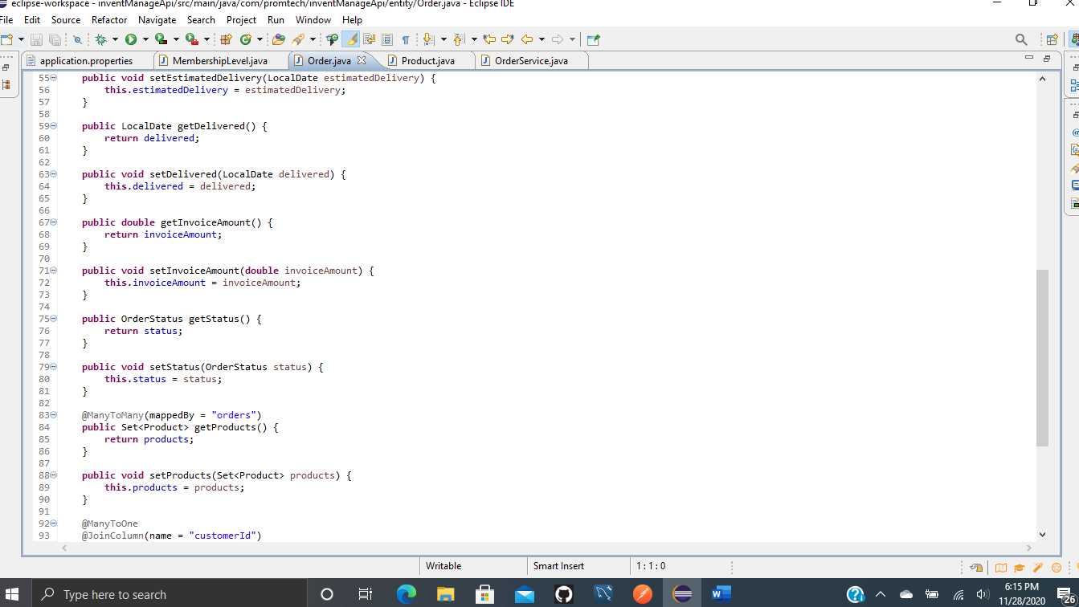

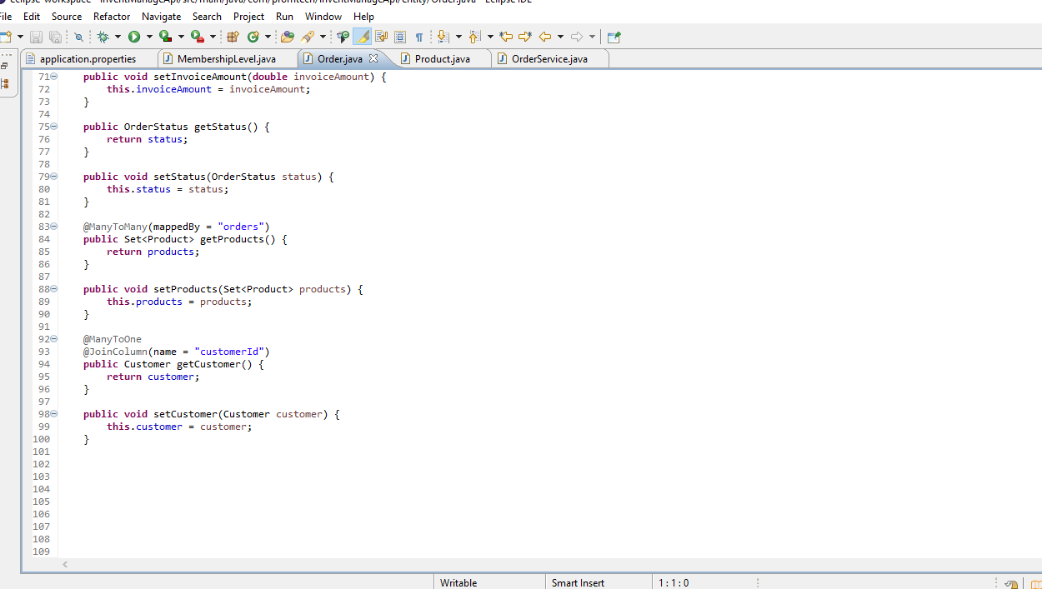

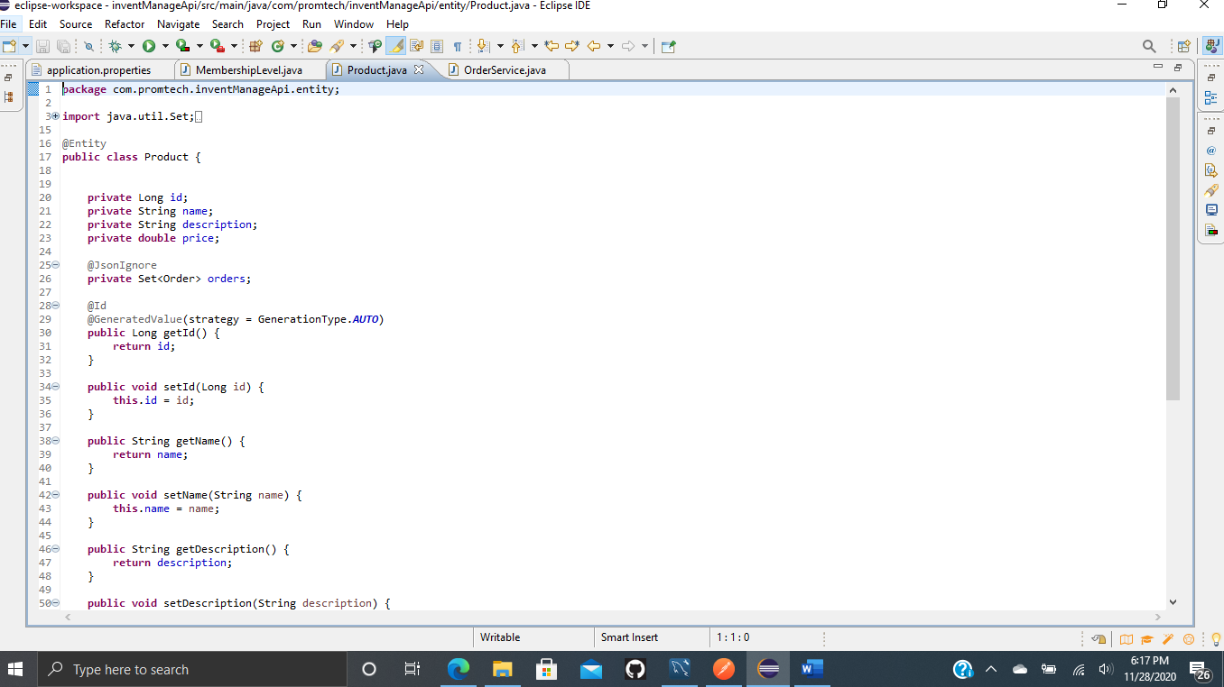

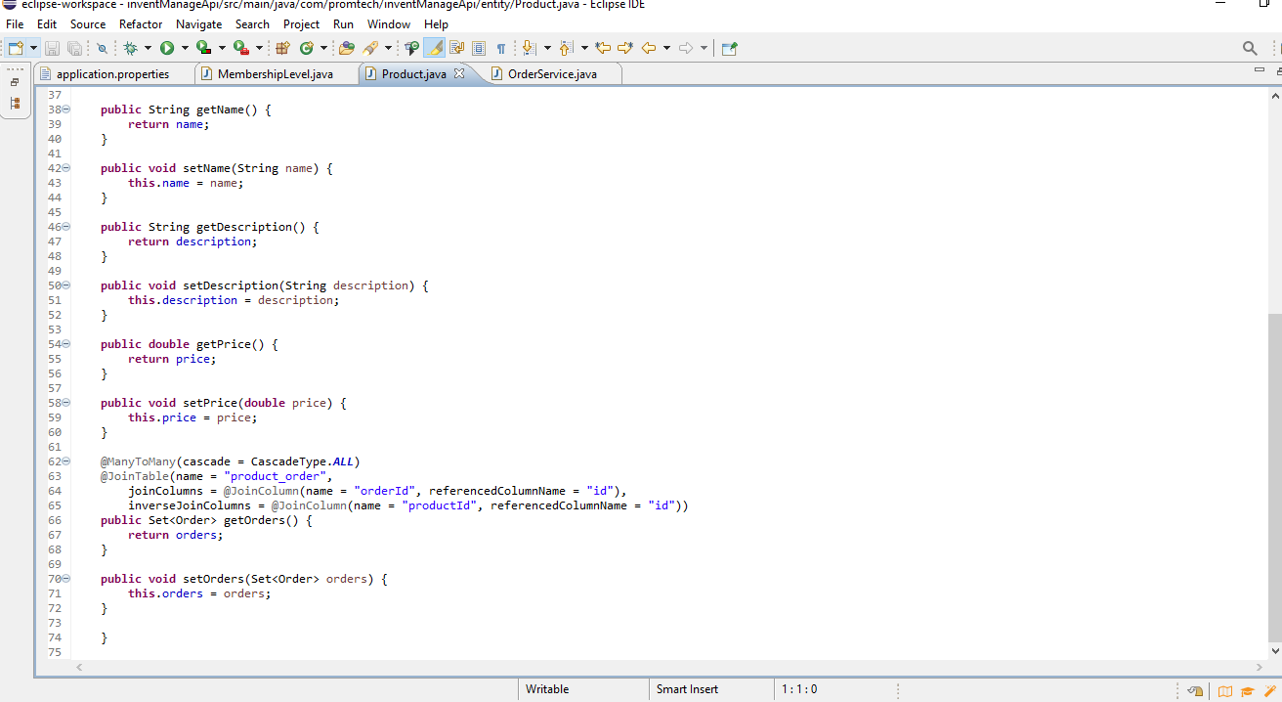

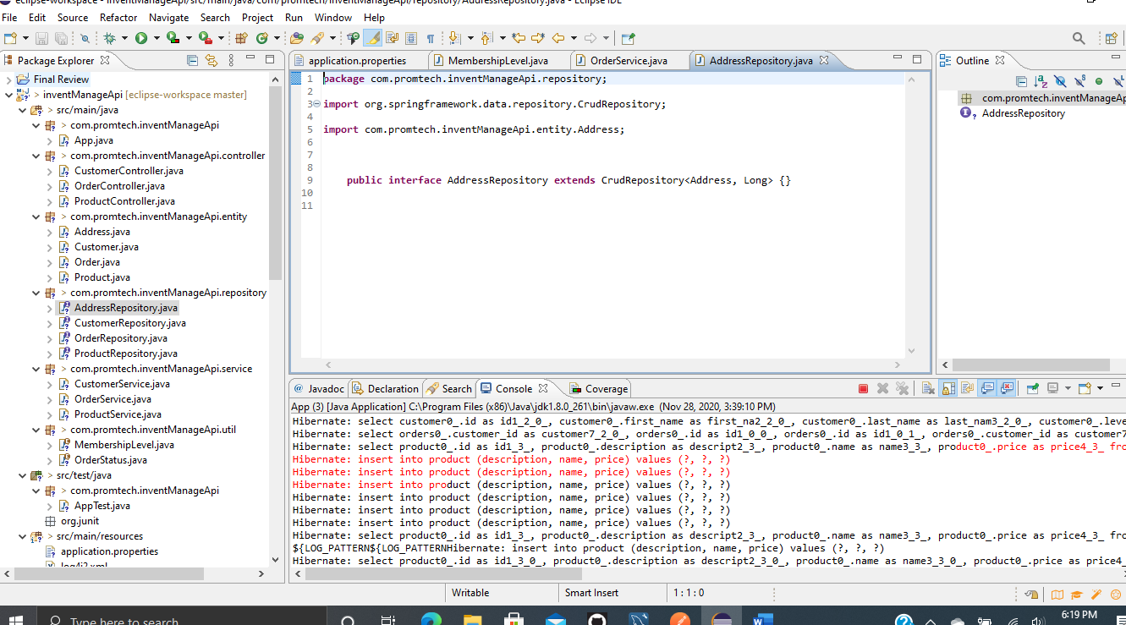

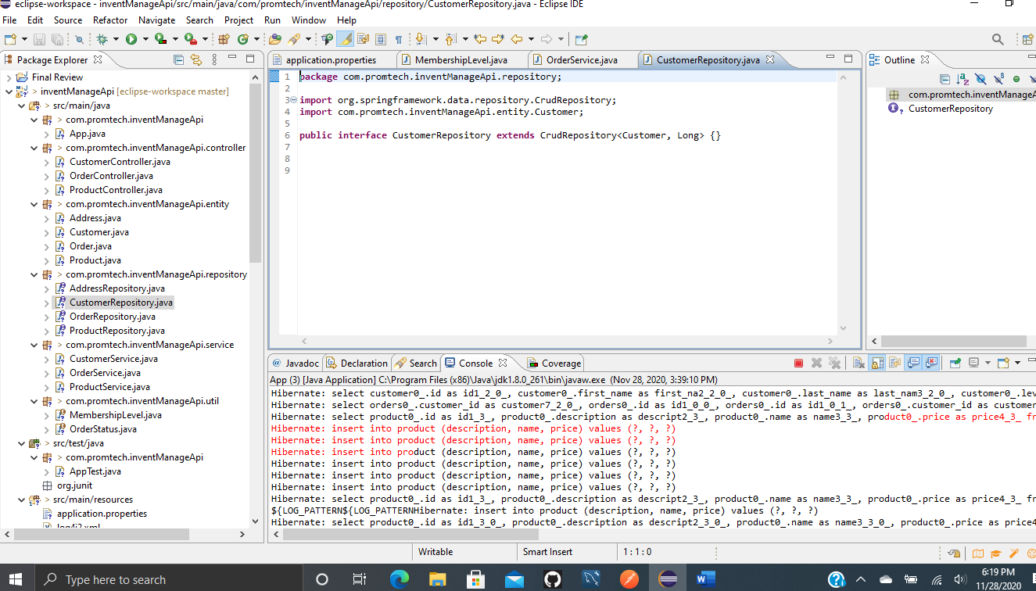

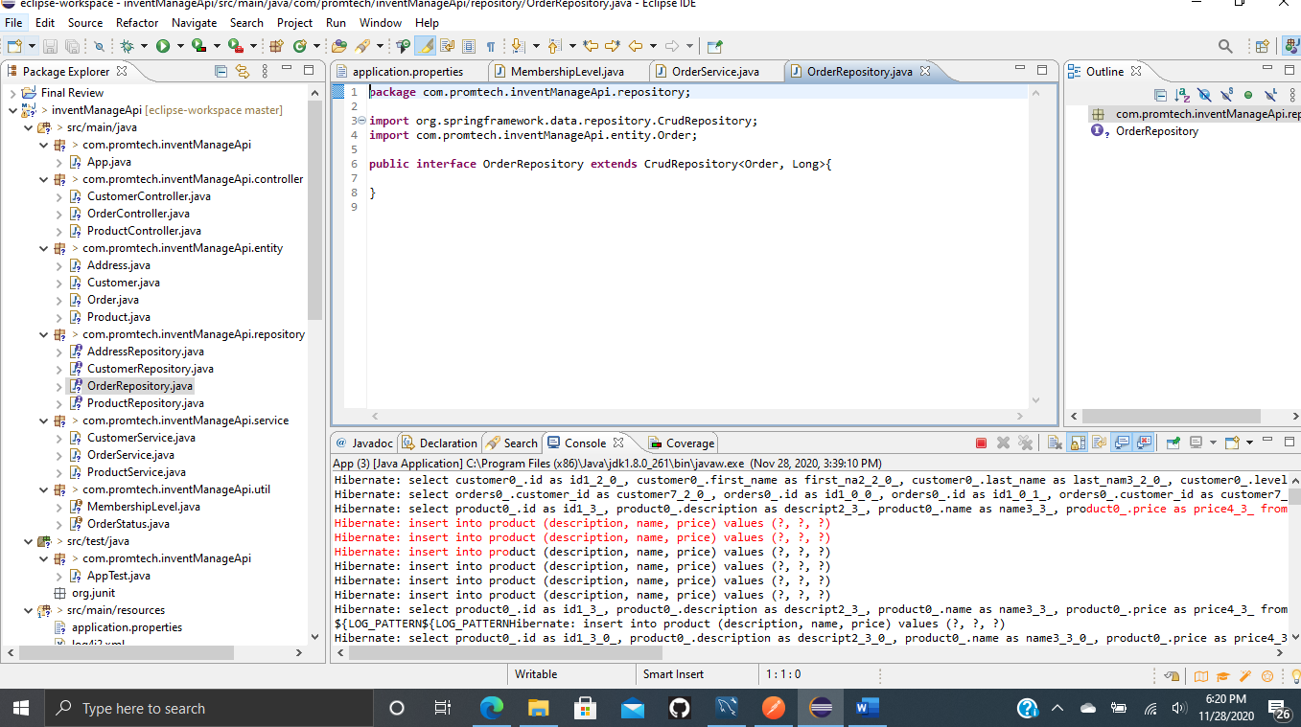

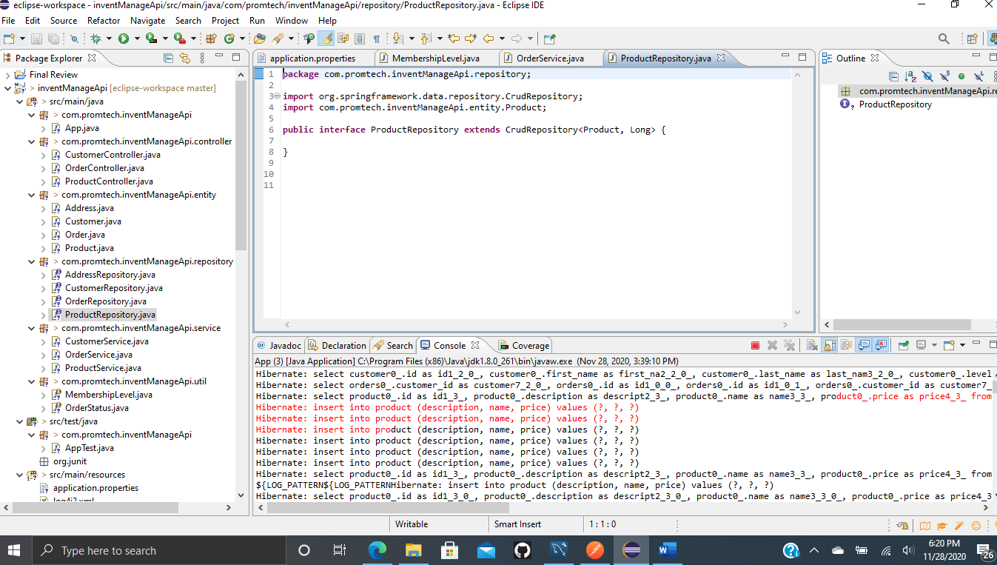

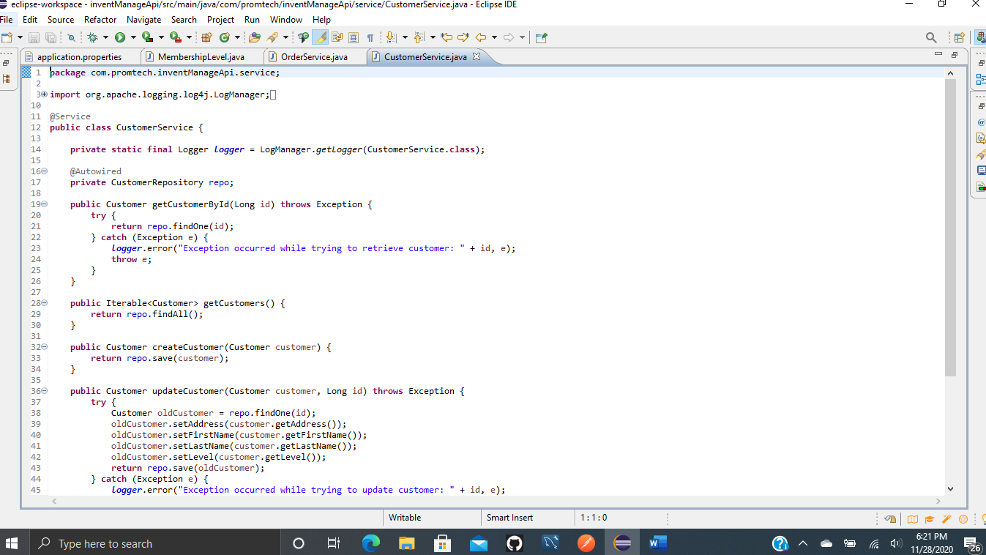

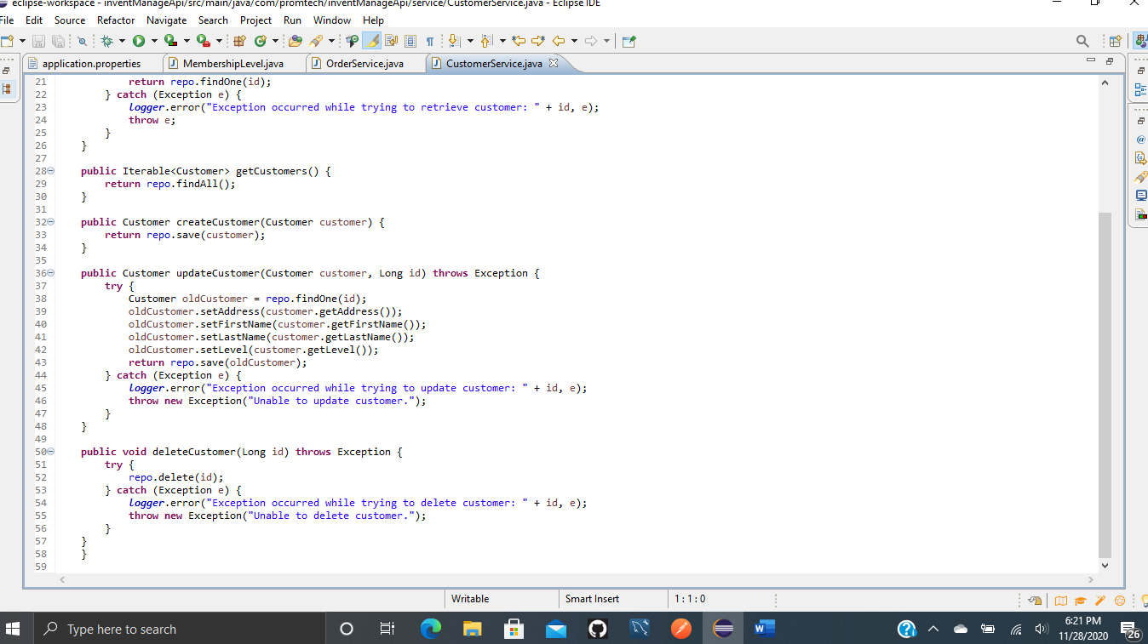

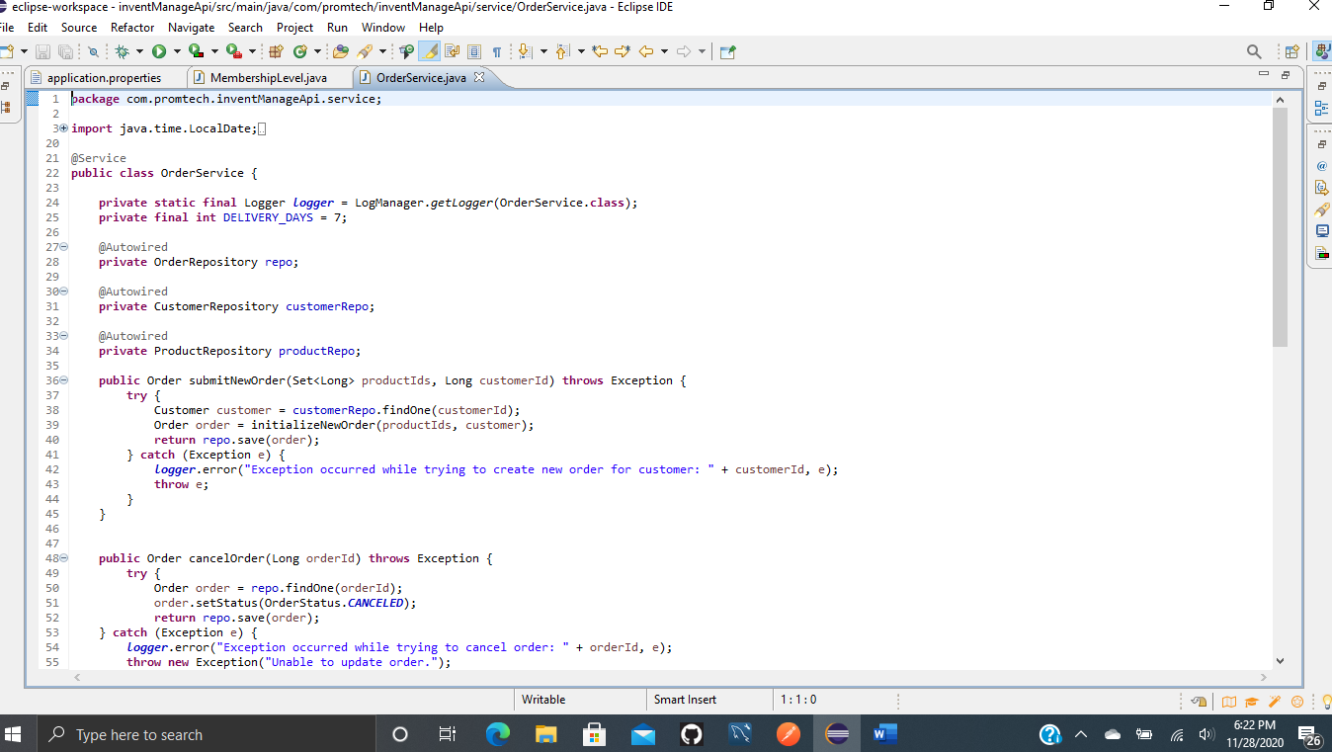

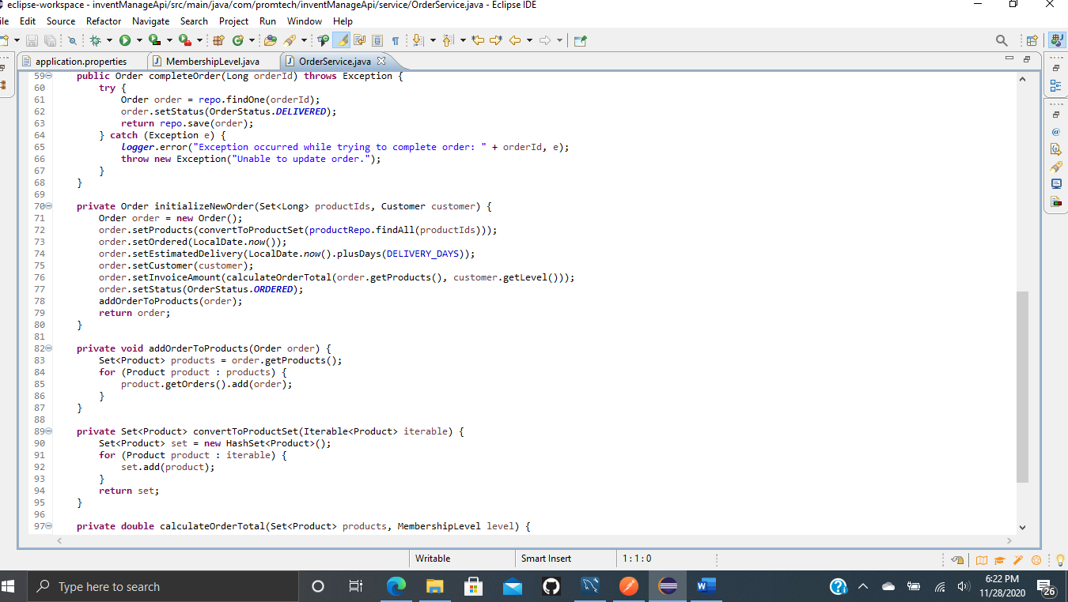

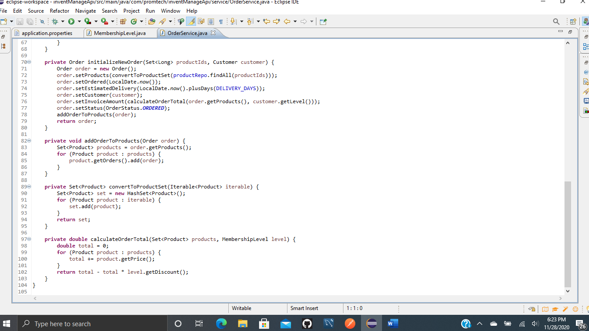

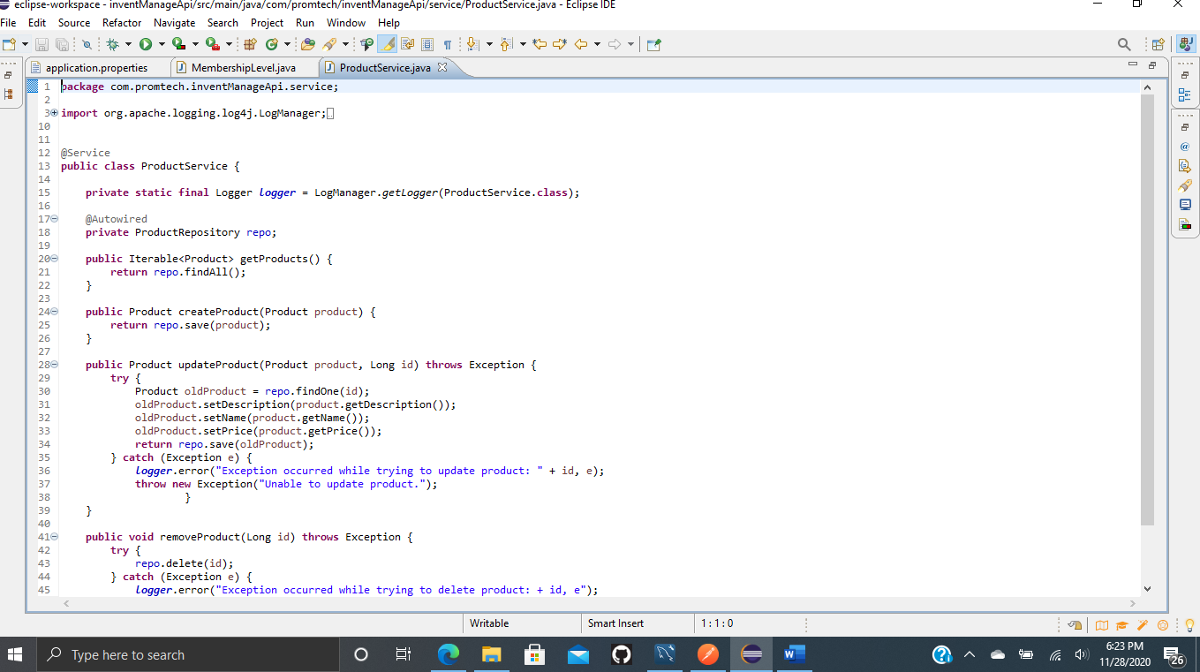

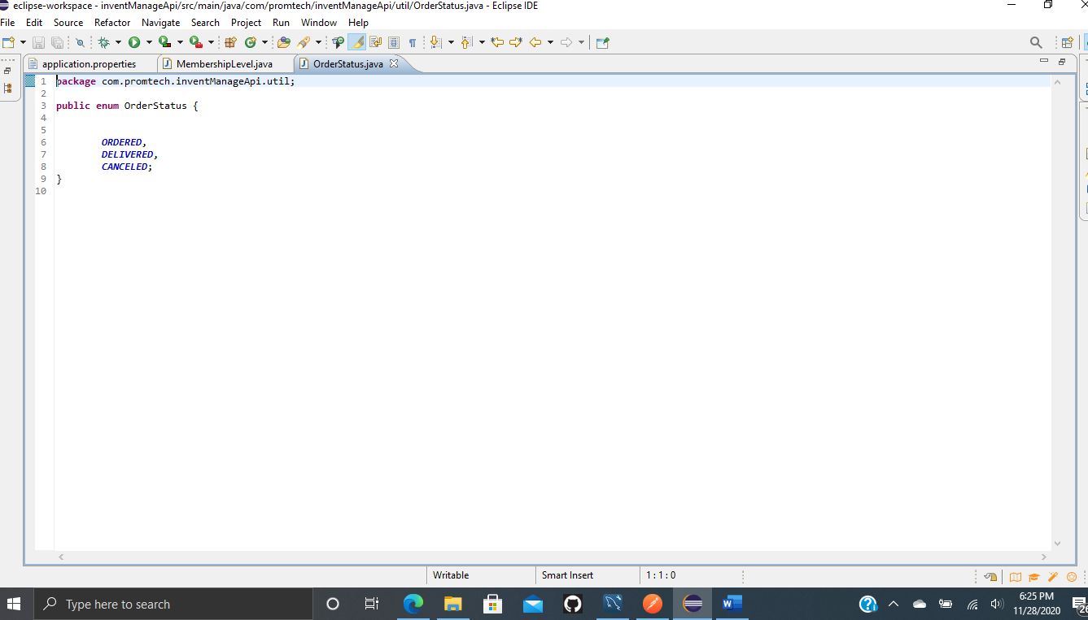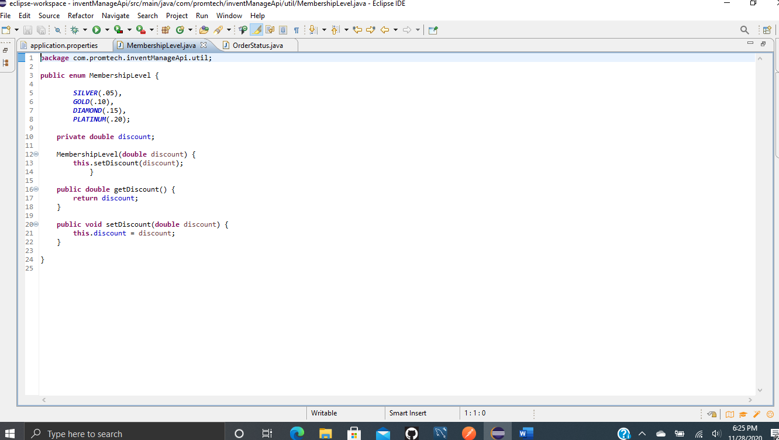

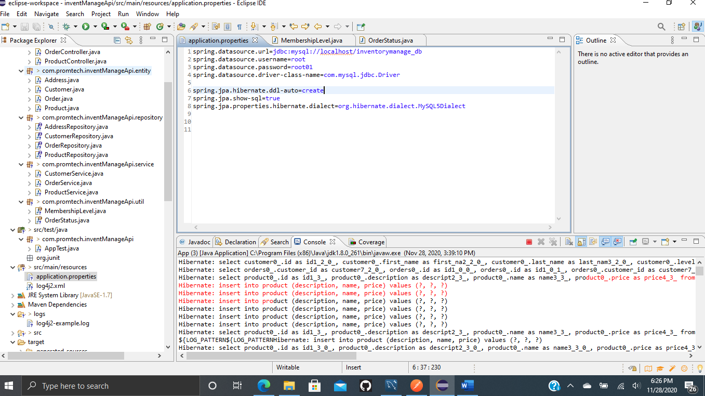

**Screenshots of Running Application:**

**PostMan Show Customers:**

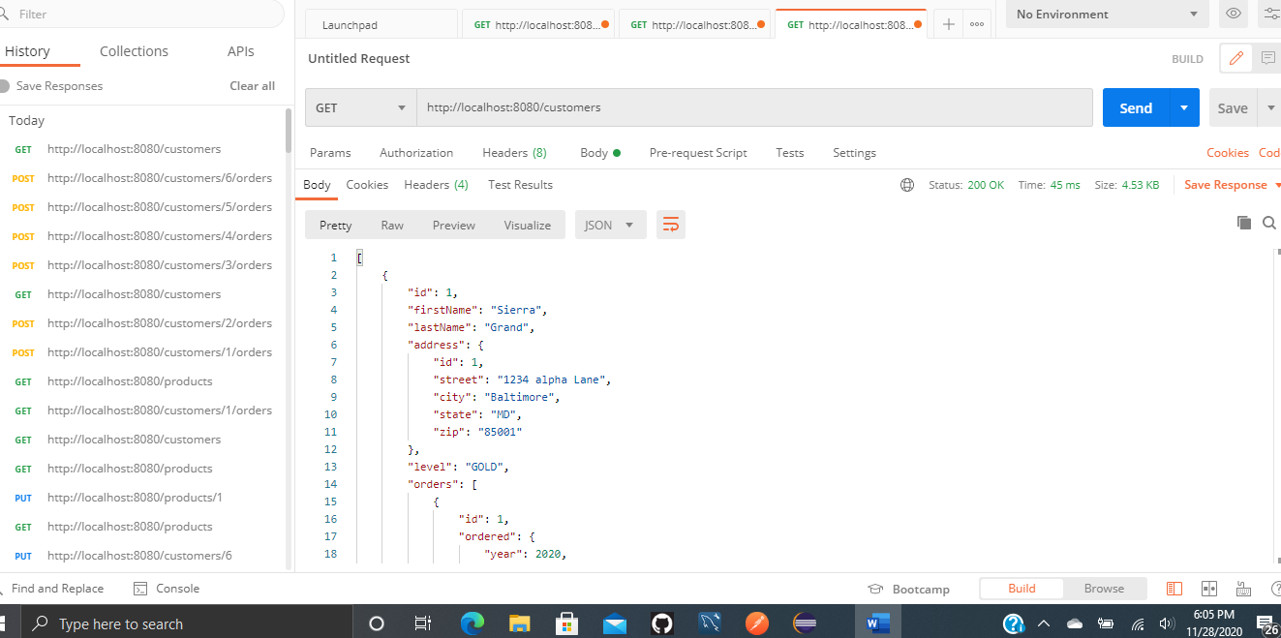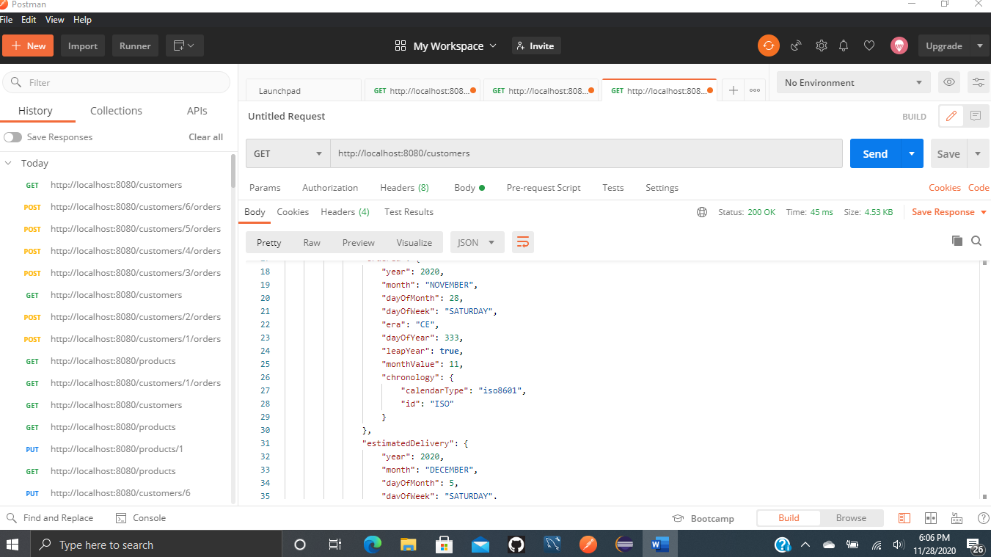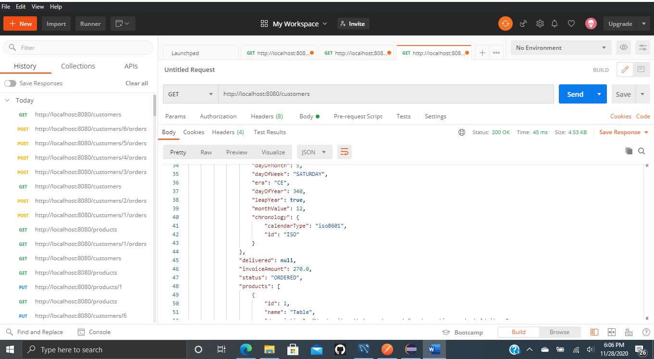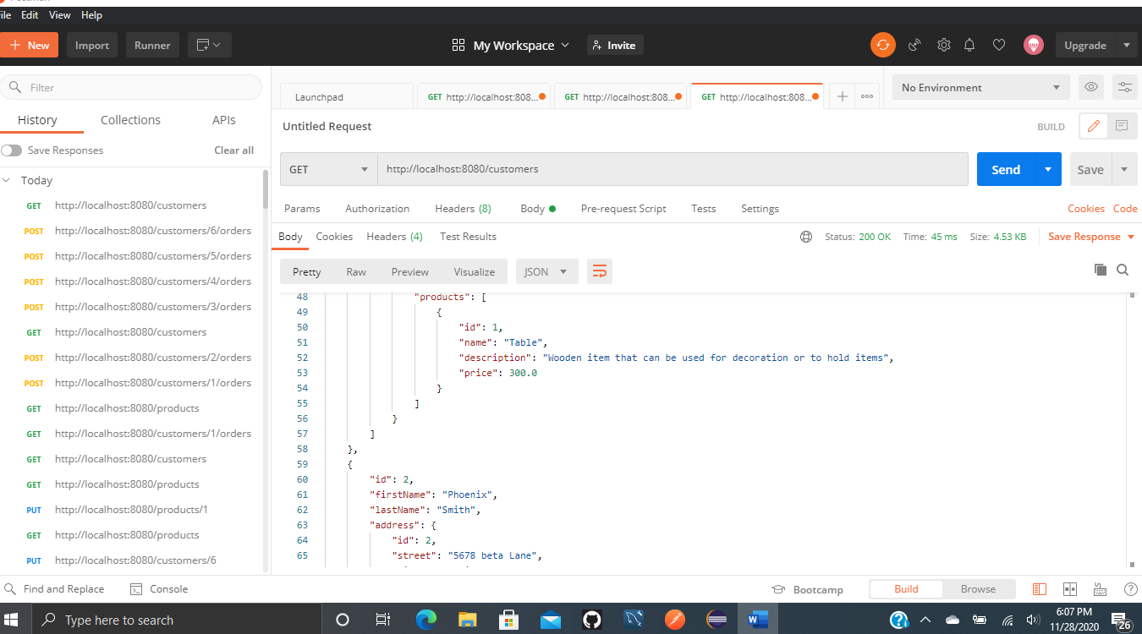

**Delete Customer:**

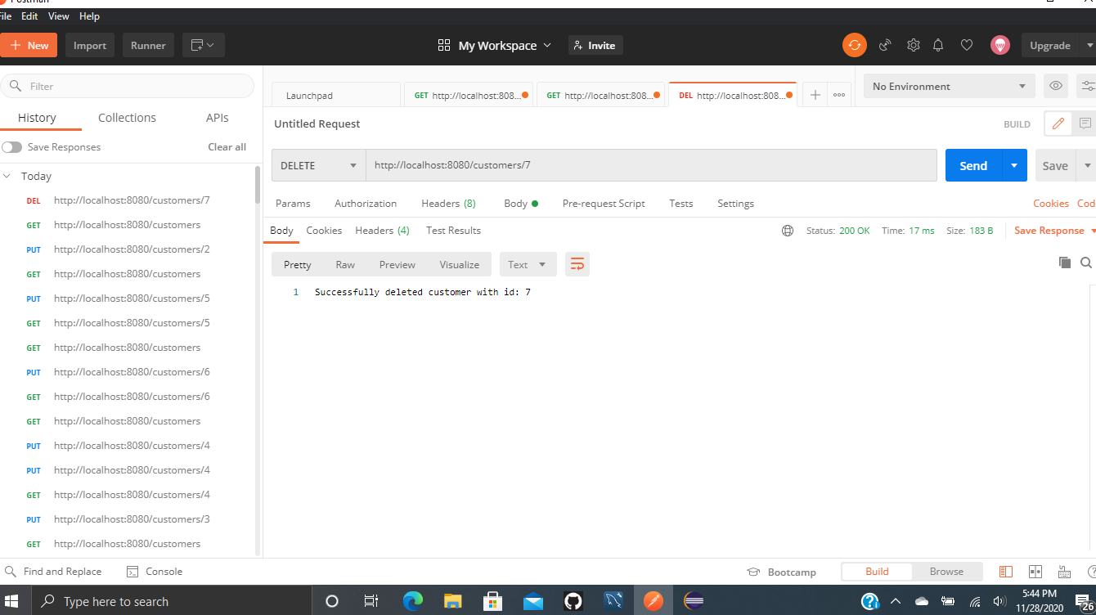

**Update Customer:**

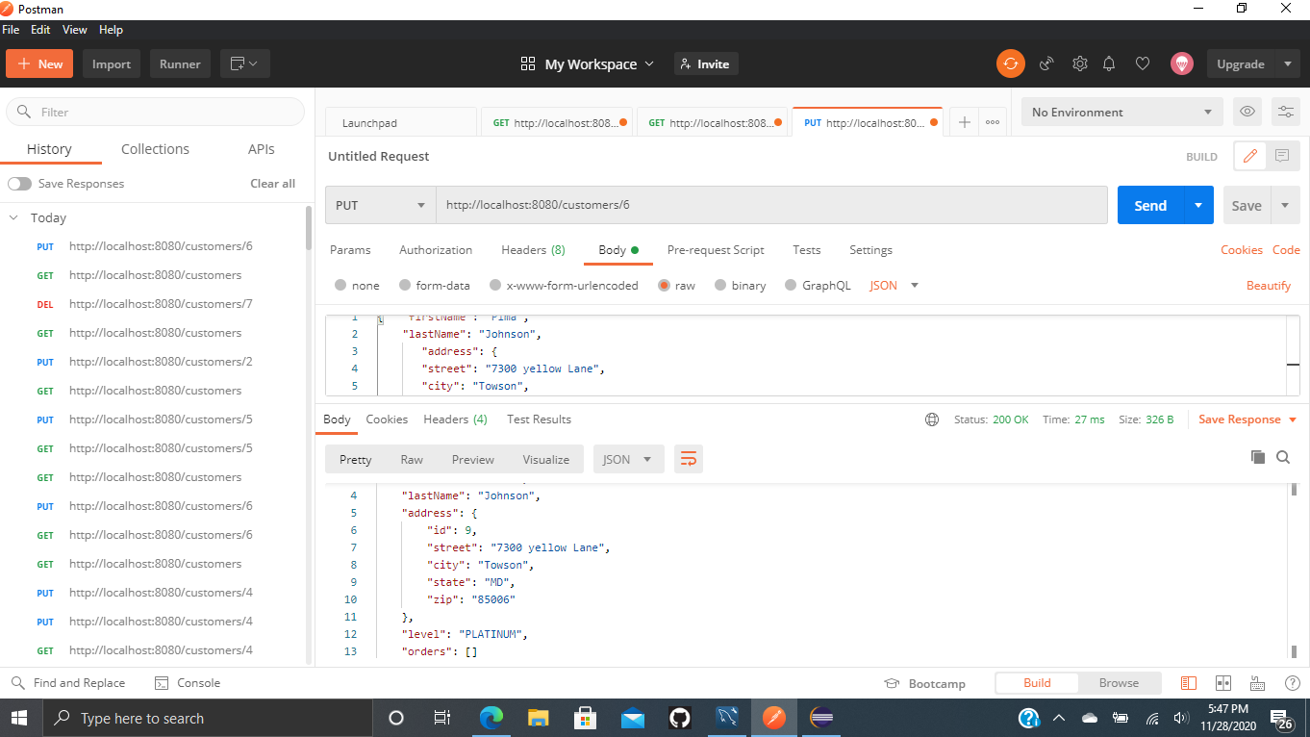

**Create Customer:**

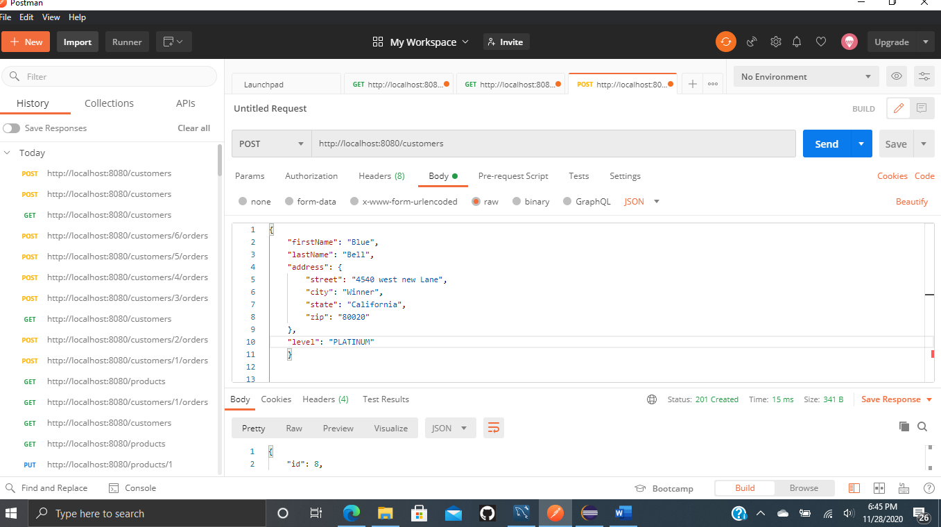

**Create Product:**

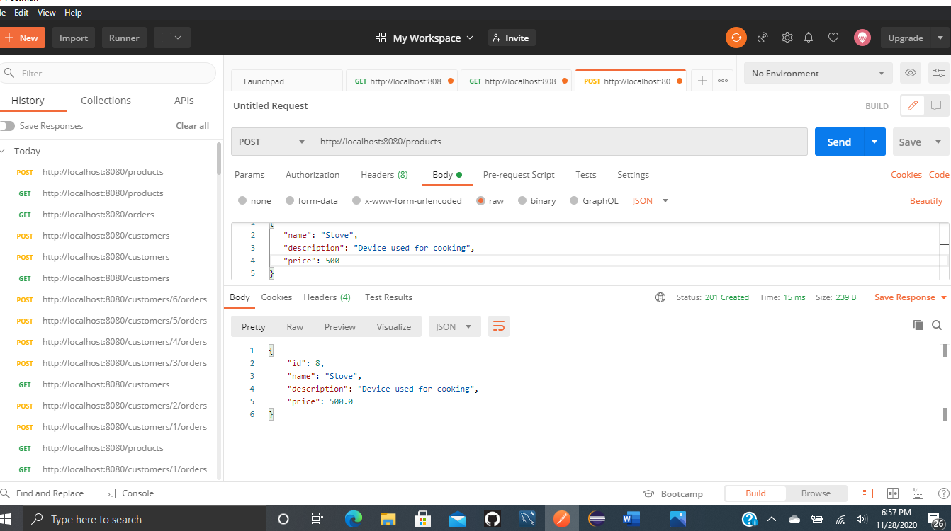

**Update Product:**

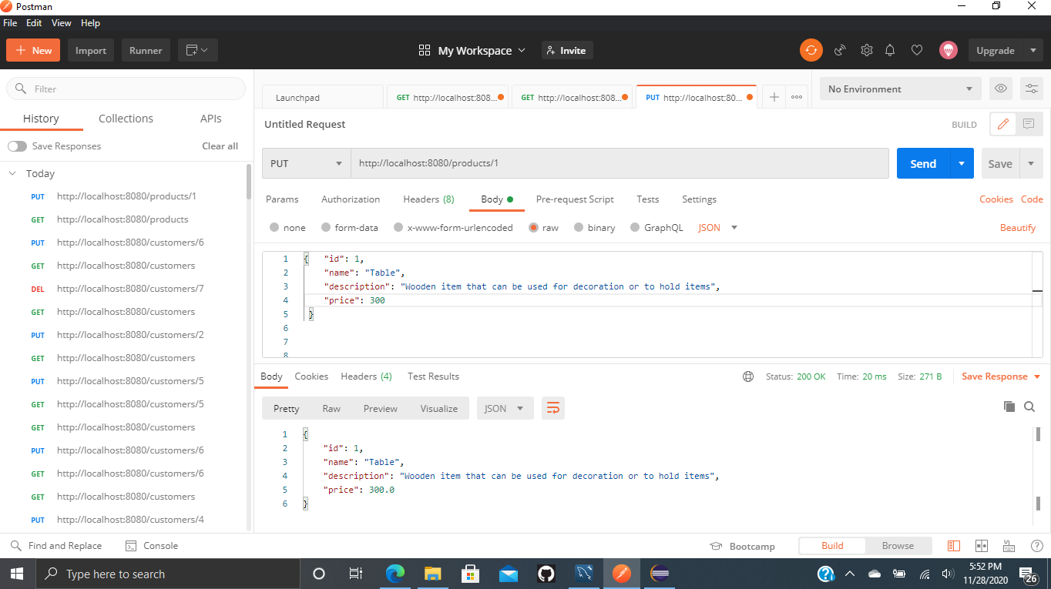

**Delete Product:**

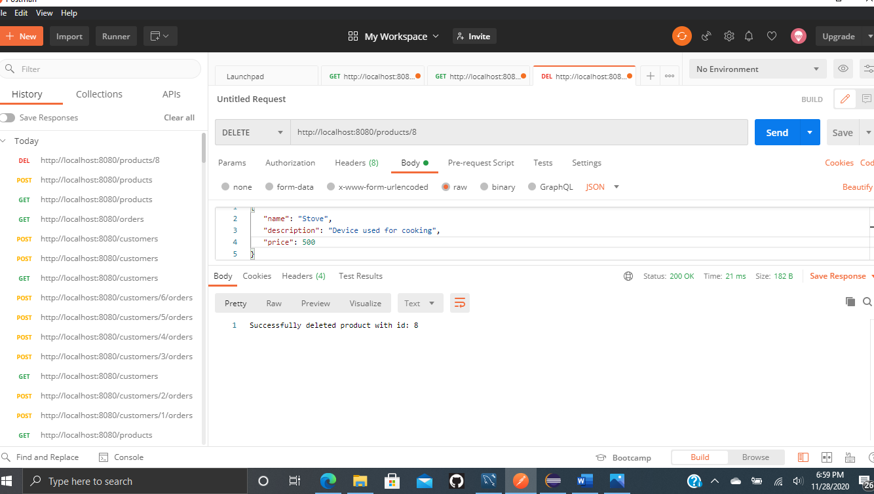

**Create Order:**

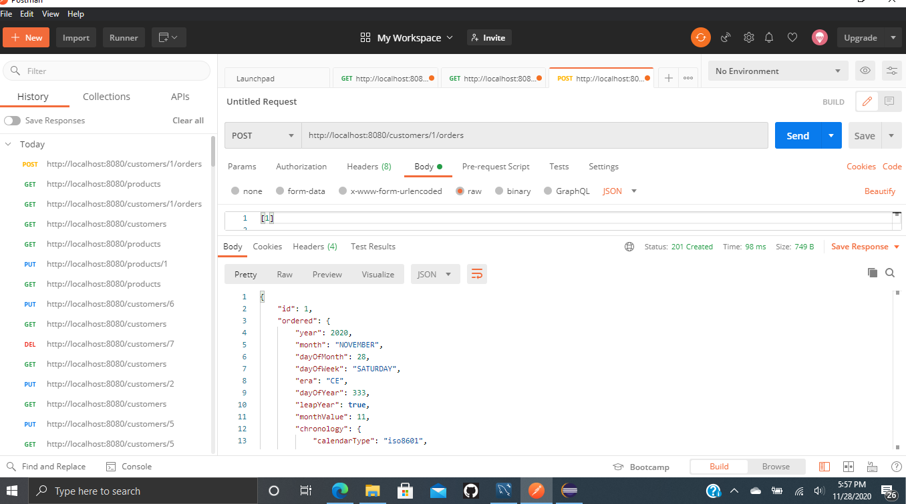

**URL to GitHub Repository:**

[**https://github.com/tjsun15/Spring-week2.git**](https://github.com/tjsun15/Spring-week2.git)